Basis Data Part 10
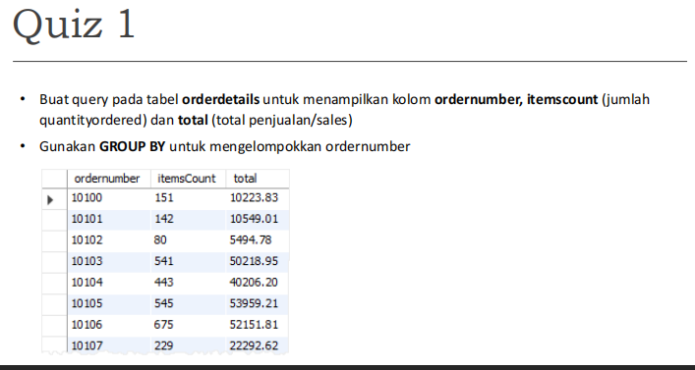
SELECT
ordernumber,
SUM(quantityOrdered) AS itemsCount,
SUM(quantityOrdered * priceEach) AS total
FROM orderdetails
GROUP BY ordernumber;
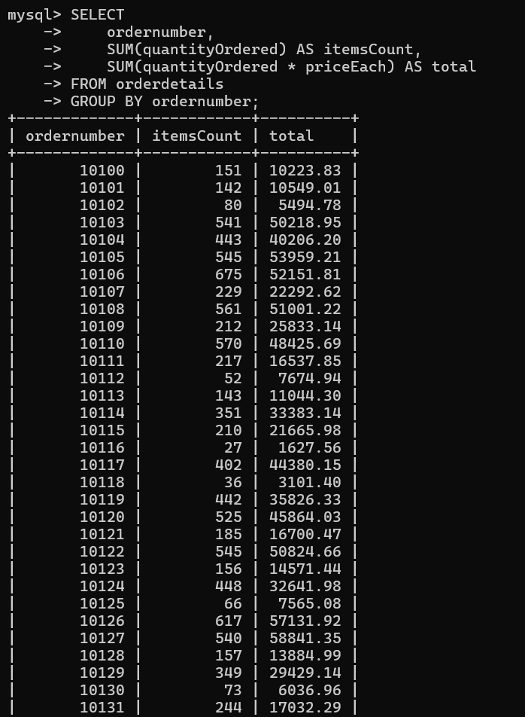
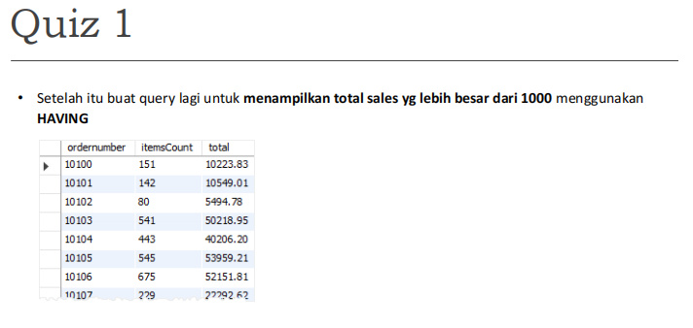
SELECT
ordernumber,
SUM(quantityOrdered) AS itemsCount,
SUM(quantityOrdered * priceEach) AS total
FROM orderdetails
GROUP BY ordernumber
HAVING total > 1000;
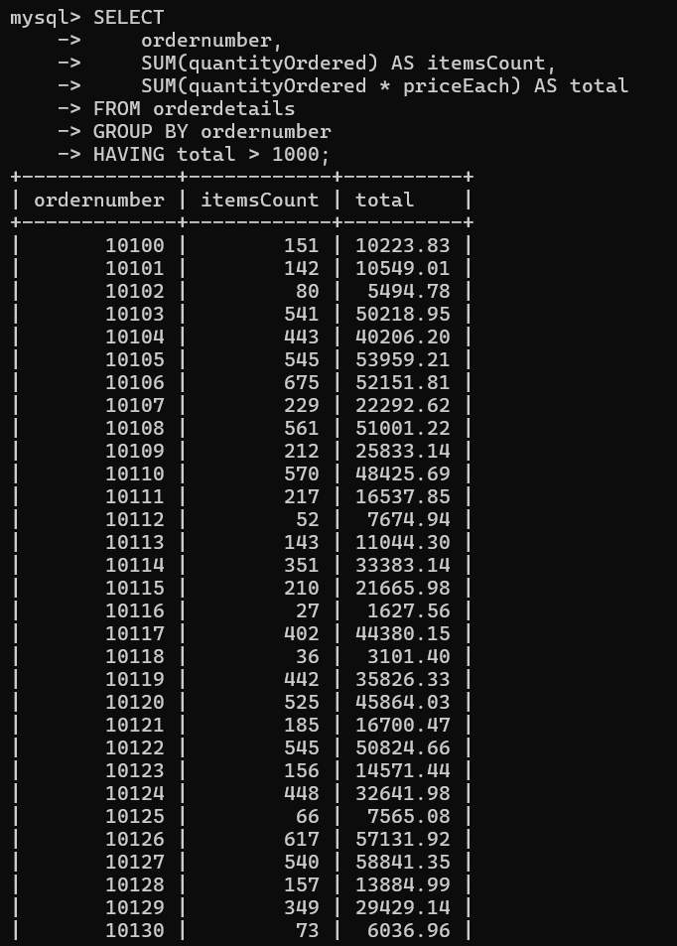

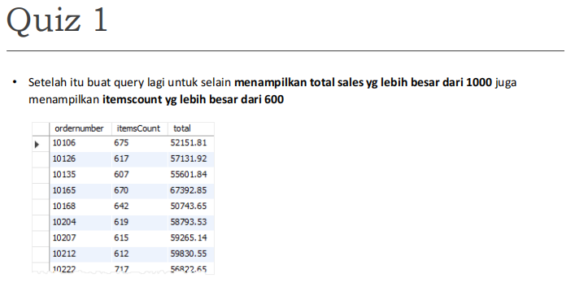
SELECT
ordernumber,
SUM(quantityOrdered) AS itemsCount,
SUM(quantityOrdered * priceEach) AS total
FROM orderdetails
GROUP BY ordernumber
HAVING total > 1000
AND itemsCount > 600;
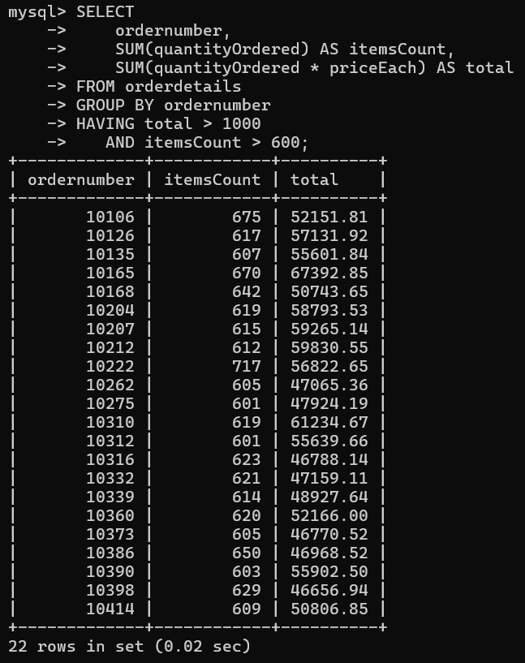
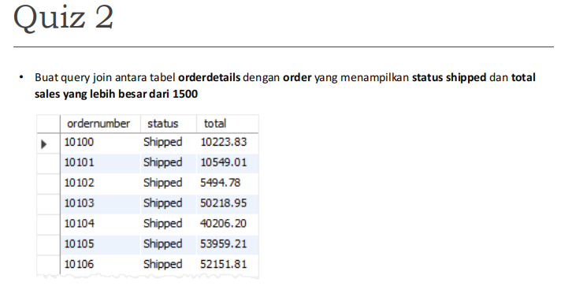
SELECT
o.ordernumber,
o.status,
SUM(od.quantityOrdered * od.priceEach) AS total
FROM orders o
JOIN orderdetails od
ON o.ordernumber = od.ordernumber
WHERE o.status = 'Shipped'
GROUP BY o.ordernumber, o.status
HAVING total > 1500;
